**29)**

**Aim:** To Design Deterministic Finite Automata using simulator to accept the input string “bc” ,”c”,and ”bcaaa”.

**Diagram:**

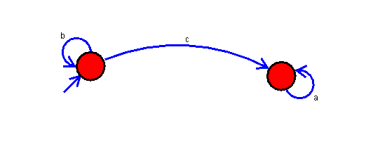

**Result:**

Thus, successfully Executed Deterministic Finite Automata using simulator to accept the input string “bc” ,”c”,and ”bcaaa”.